
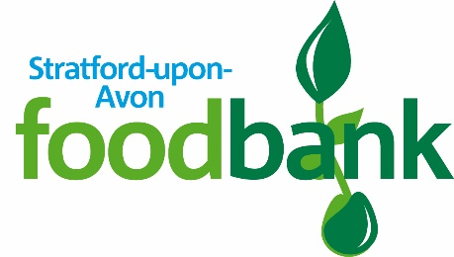
December 2022
for your amazing donation to
Stratford-upon-Avon Foodbank
to help local children and their families
Alveston Primary School
a big thank you

