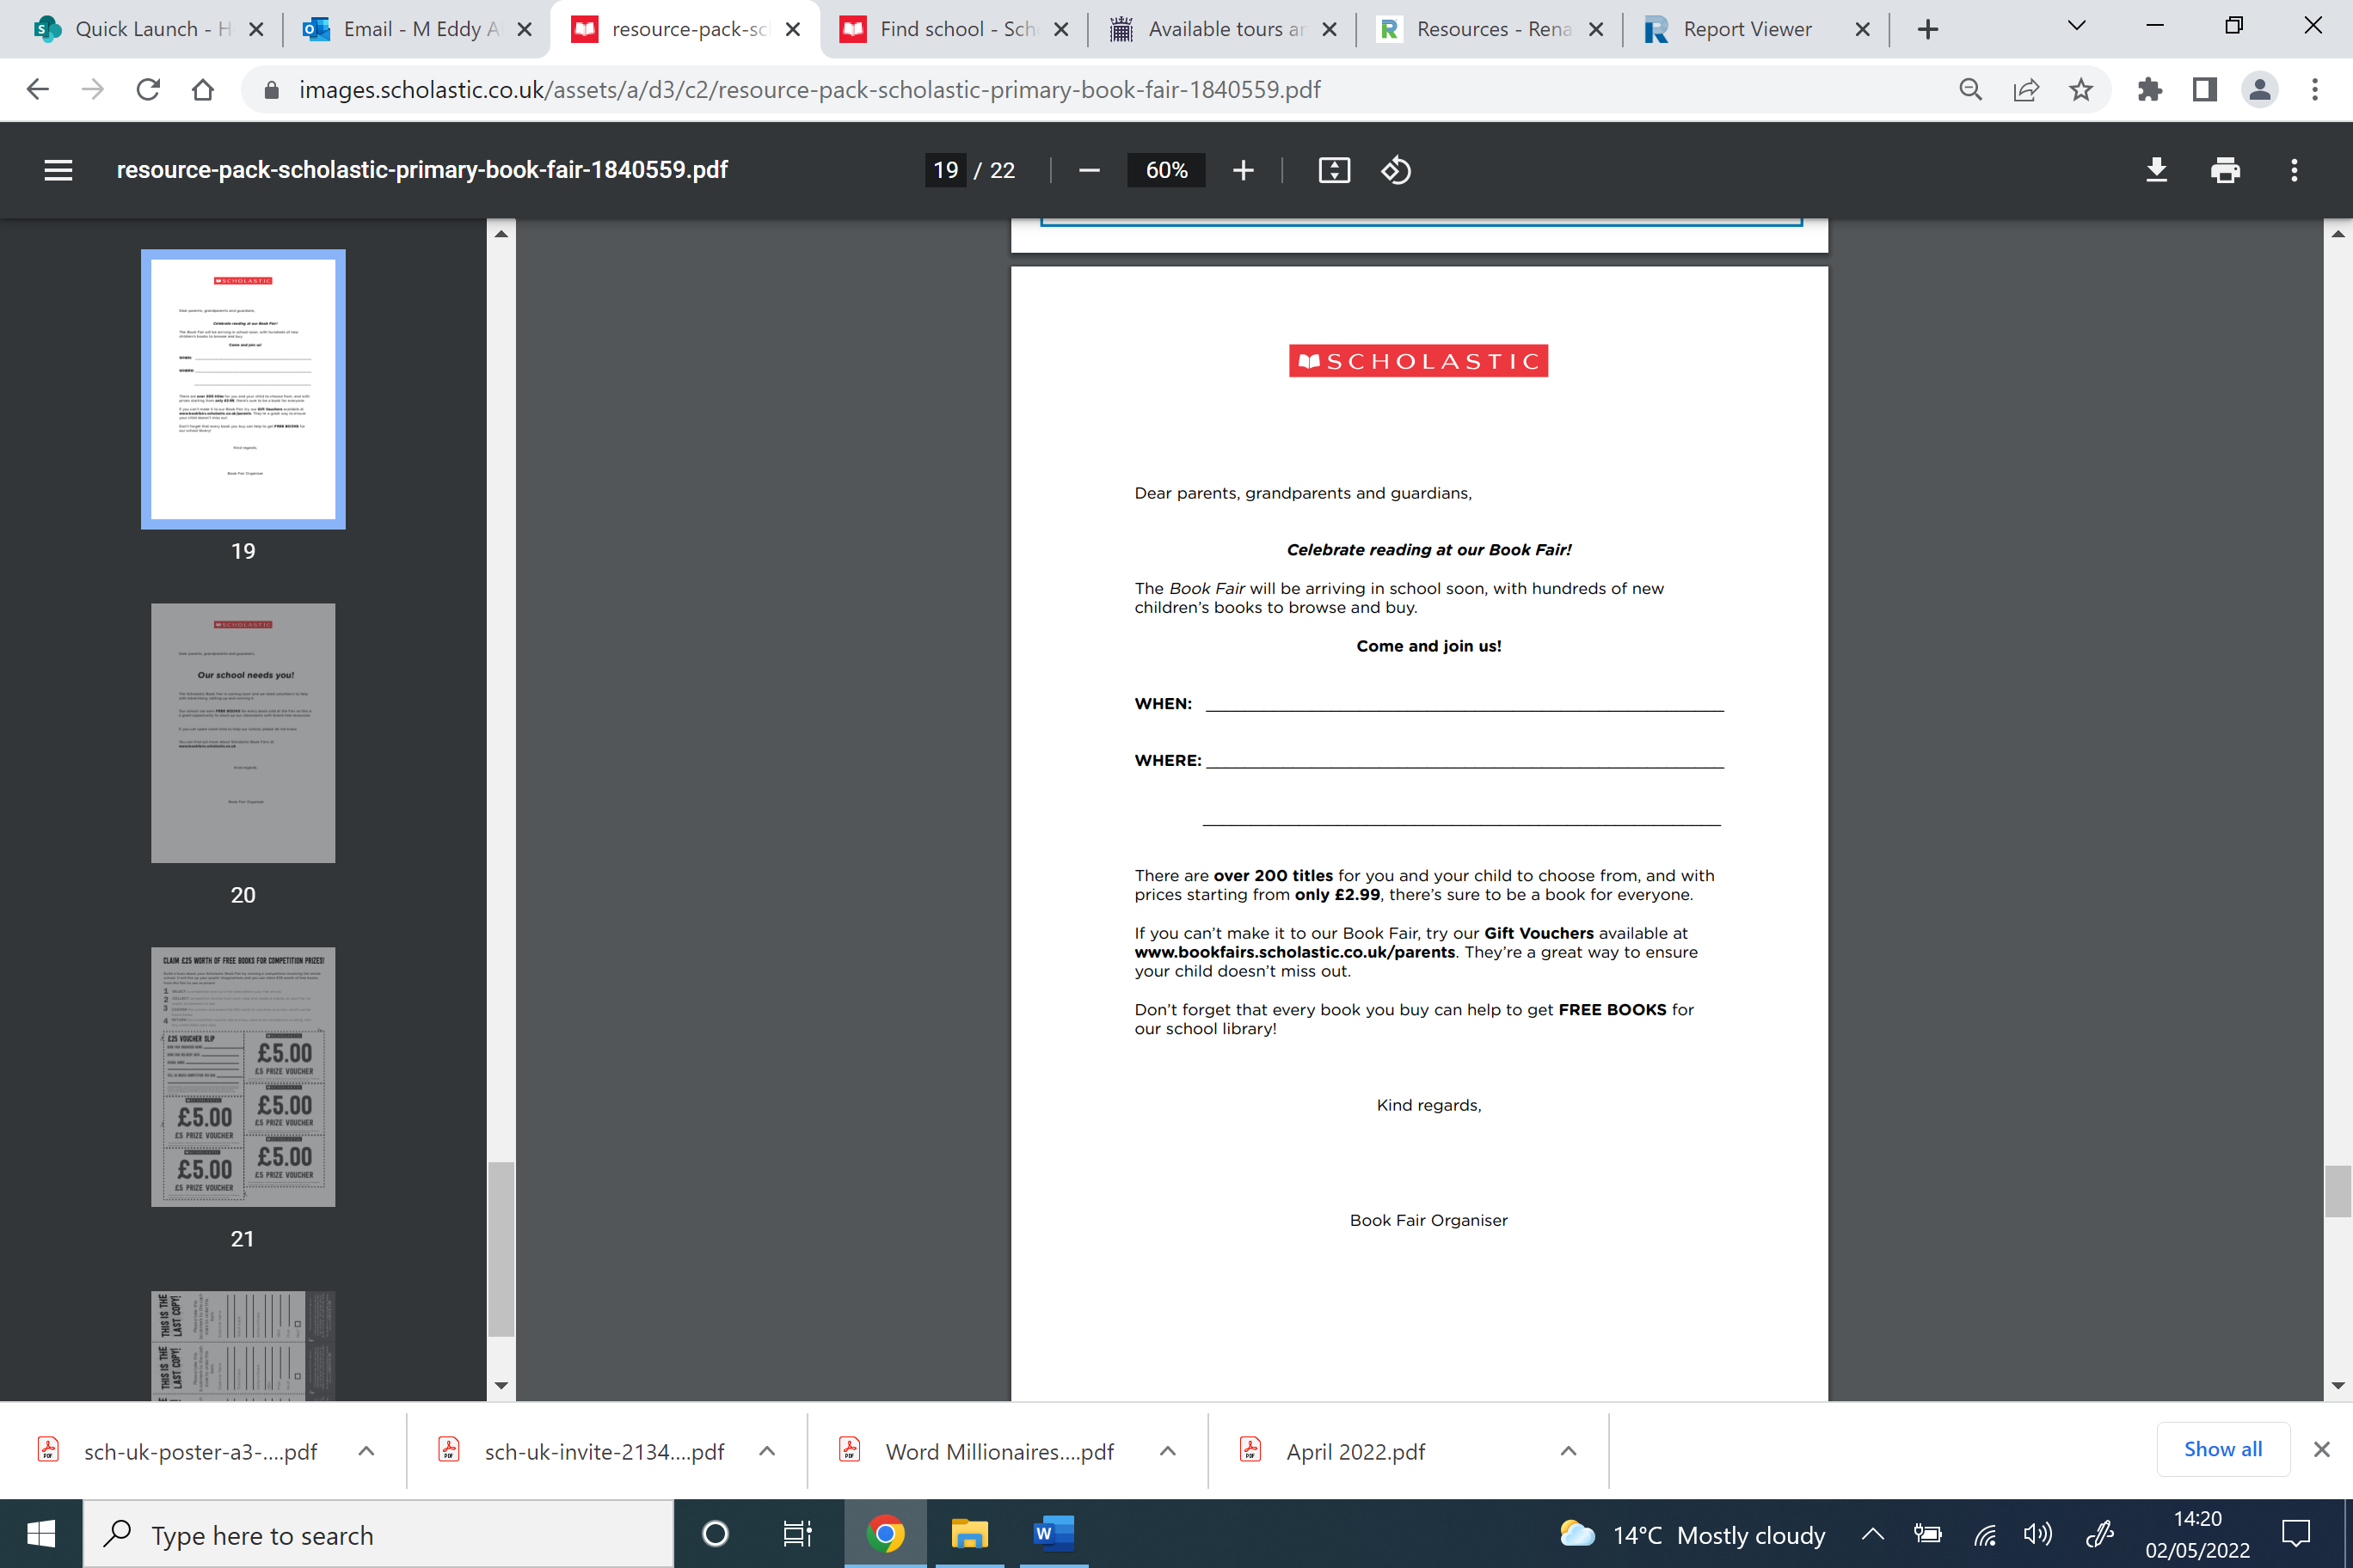

Alveston C of E Primary School

Community room

Monday 20th November – Friday 24th November

3.15 – 4pm every day.

Miss Griffiths

***Please note that payments are cashless.***

*Pay using a contactless card reader or online on the day by using a QR code on your phone/school iPads.*