 | 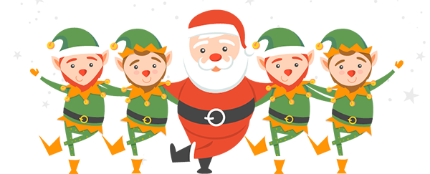

SANTA IS COMING TO STRATFORD!

Shakespeare Lions are delighted to confirm that Santa will once again be visiting Stratford in December and has asked the Lions to help him while he tours around in his sleigh. He is also hoping to catchup with some of his fans at Morrisons, Tesco, Maybird and at a couple of markets in town.
Santa will be joined by a number of elves carrying collection buckets if anyone wants to fling in coins or notes. An alternative of donating by phone or online will be available. As usual, any monies raised will be used to support groups and individuals in our local area.
Full details about routes, dates and times can be found on our website together with information about how to track Santa online during his tours around the town!

www.shakespearelions.com
www.facebook.com/StratfordLions1

www.instagram.com/shakespearelionsclub/

